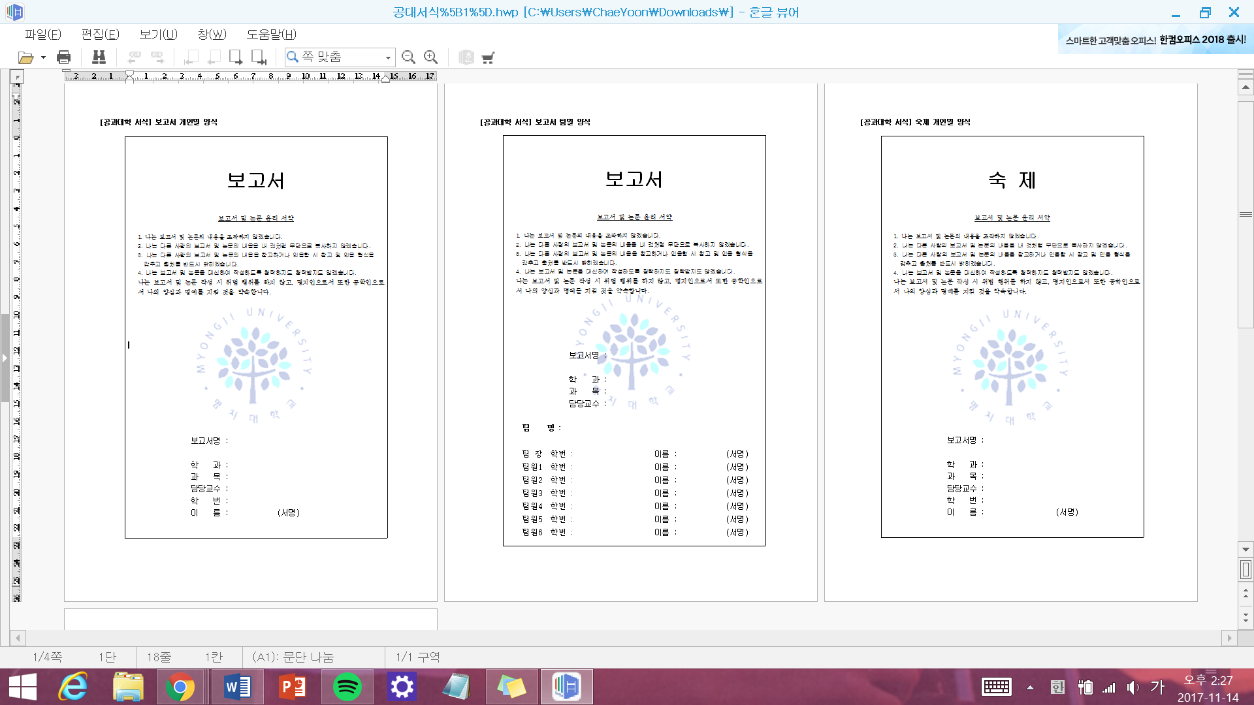

패킷 트레이서 프로젝트

정보통신공학과

통신 네트워크

김세목

60131993

이채윤

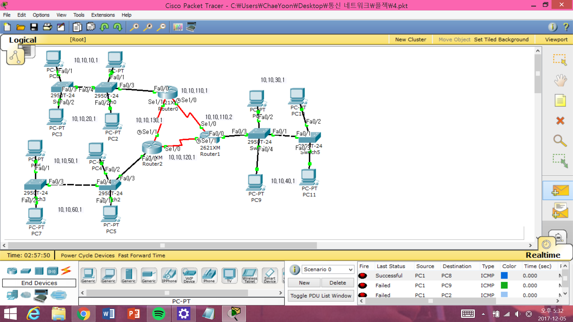

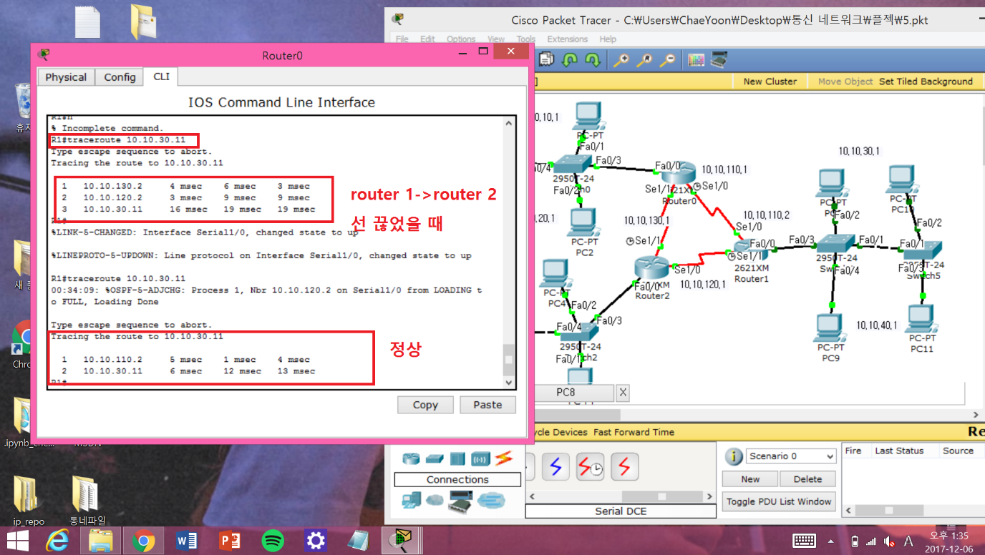

옵션

Config

1. Config 라우터
   1. **라우터1**

R1#show running-config

Building configuration...

Current configuration : 1967 bytes

!

version 12.2

no service timestamps log datetime msec

no service timestamps debug datetime msec

no service password-encryption

!

hostname R1

!

!

!

!

!

!

!

!

!

!

!

!

no ip domain-lookup

!

!

!

!

!

!

interface FastEthernet0/0

no ip address

duplex auto

speed auto

!

interface FastEthernet0/0.1

encapsulation dot1Q 10

ip address 10.10.10.1 255.255.255.0

ip access-group 10 in

ip access-group 10 out

!

interface FastEthernet0/0.2

encapsulation dot1Q 20

ip address 10.10.20.1 255.255.255.0

ip access-group 20 out

!

interface FastEthernet0/0.10

no ip address

ip access-group 10 out

!

interface FastEthernet0/0.20

no ip address

ip access-group 20 out

!

interface FastEthernet0/1

no ip address

duplex auto

speed auto

shutdown

!

interface Serial1/0

ip address 10.10.110.1 255.255.255.0

ip ospf priority 1

clock rate 9600

!

interface Serial1/1

ip address 10.10.130.1 255.255.255.0

ip ospf priority 10

!

interface Serial1/2

no ip address

clock rate 2000000

shutdown

!

interface Serial1/3

no ip address

clock rate 2000000

shutdown

!

interface Serial1/4

no ip address

clock rate 2000000

shutdown

!

interface Serial1/5

no ip address

clock rate 2000000

shutdown

!

interface Serial1/6

no ip address

clock rate 2000000

shutdown

!

interface Serial1/7

no ip address

clock rate 2000000

shutdown

!

router ospf 1

log-adjacency-changes

network 10.10.10.0 0.0.0.255 area 1

network 10.10.20.0 0.0.0.255 area 1

network 10.10.110.0 0.0.0.255 area 1

network 10.10.130.0 0.0.0.255 area 1

!

ip classless

ip route 10.10.30.0 255.255.255.0 10.10.110.2

ip route 10.10.40.0 255.255.255.0 10.10.110.2

!

!

access-list 20 deny 10.10.10.0 0.0.0.255

access-list 20 deny 10.10.30.0 0.0.0.255

access-list 20 deny 10.10.50.0 0.0.0.255

access-list 20 permit any

access-list 10 deny 10.10.20.0 0.0.0.255

access-list 10 deny 10.10.40.0 0.0.0.255

access-list 10 deny 10.10.60.0 0.0.0.255

access-list 10 permit any

!

!

!

!

!

line con 0

line vty 0 4

login

!

!

!

end

* 1. **라우터 2**

R2#show running-config

Building configuration...

Current configuration : 1896 bytes

!

version 12.2

no service timestamps log datetime msec

no service timestamps debug datetime msec

no service password-encryption

!

hostname R2

!

!

!

!

!

!

!

!

!

!

!

!

no ip domain-lookup

!

!

!

!

!

!

interface FastEthernet0/0

no ip address

duplex auto

speed auto

!

interface FastEthernet0/0.1

encapsulation dot1Q 10

ip address 10.10.30.1 255.255.255.0

ip access-group 10 out

!

interface FastEthernet0/0.2

encapsulation dot1Q 20

ip address 10.10.40.1 255.255.255.0

ip access-group 20 out

!

interface FastEthernet0/0.10

no ip address

ip access-group 10 in

ip access-group 10 out

!

interface FastEthernet0/0.20

no ip address

ip access-group 20 in

ip access-group 20 out

!

interface FastEthernet0/1

no ip address

duplex auto

speed auto

shutdown

!

interface Serial1/0

ip address 10.10.110.2 255.255.255.0

ip ospf priority 10

!

interface Serial1/1

ip address 10.10.120.2 255.255.255.0

ip ospf priority 1

clock rate 9600

!

interface Serial1/2

no ip address

clock rate 2000000

shutdown

!

interface Serial1/3

no ip address

clock rate 2000000

shutdown

!

interface Serial1/4

no ip address

clock rate 2000000

shutdown

!

interface Serial1/5

no ip address

clock rate 2000000

shutdown

!

interface Serial1/6

no ip address

clock rate 2000000

shutdown

!

interface Serial1/7

no ip address

clock rate 2000000

shutdown

!

router ospf 1

log-adjacency-changes

network 10.10.110.0 0.0.0.255 area 1

network 10.10.120.0 0.0.0.255 area 1

network 10.10.30.0 0.0.0.255 area 1

network 10.10.40.0 0.0.0.255 area 1

!

ip classless

!

!

access-list 10 deny 10.10.20.0 0.0.0.255

access-list 10 deny 10.10.40.0 0.0.0.255

access-list 10 deny 10.10.60.0 0.0.0.255

access-list 10 permit any

access-list 20 deny 10.10.10.0 0.0.0.255

access-list 20 deny 10.10.30.0 0.0.0.255

access-list 20 deny 10.10.50.0 0.0.0.255

access-list 20 permit any

!

!

!

!

!

line con 0

line vty 0 4

login

!

!

!

end

* 1. **라우터 3**

R3#show running-config

Building configuration...

Current configuration : 1853 bytes

!

version 12.2

no service timestamps log datetime msec

no service timestamps debug datetime msec

no service password-encryption

!

hostname R3

!

!

!

!

!

!

!

!

!

!

!

!

!

!

!

!

!

!

interface FastEthernet0/0

no ip address

duplex auto

speed auto

!

interface FastEthernet0/0.1

encapsulation dot1Q 10

ip address 10.10.50.1 255.255.255.0

ip access-group 10 in

ip access-group 10 out

!

interface FastEthernet0/0.2

encapsulation dot1Q 20

ip address 10.10.60.1 255.255.255.0

ip access-group 20 out

!

interface FastEthernet0/0.10

no ip address

ip access-group 10 out

!

interface FastEthernet0/0.20

no ip address

ip access-group 20 out

!

interface FastEthernet0/1

no ip address

duplex auto

speed auto

shutdown

!

interface Serial1/0

ip address 10.10.120.1 255.255.255.0

ip ospf priority 10

!

interface Serial1/1

ip address 10.10.130.2 255.255.255.0

ip ospf priority 1

clock rate 9600

!

interface Serial1/2

no ip address

clock rate 2000000

shutdown

!

interface Serial1/3

no ip address

clock rate 2000000

shutdown

!

interface Serial1/4

no ip address

clock rate 2000000

shutdown

!

interface Serial1/5

no ip address

clock rate 2000000

shutdown

!

interface Serial1/6

no ip address

clock rate 2000000

shutdown

!

interface Serial1/7

no ip address

clock rate 2000000

shutdown

!

router ospf 1

log-adjacency-changes

network 10.10.120.0 0.0.0.255 area 1

network 10.10.130.0 0.0.0.255 area 1

network 10.10.50.0 0.0.0.255 area 1

network 10.10.60.0 0.0.0.255 area 1

!

ip classless

!

!

access-list 10 deny 10.10.20.0 0.0.0.255

access-list 10 deny 10.10.40.0 0.0.0.255

access-list 10 deny 10.10.60.0 0.0.0.255

access-list 10 permit any

access-list 20 deny 10.10.10.0 0.0.0.255

access-list 20 deny 10.10.30.0 0.0.0.255

access-list 20 deny 10.10.50.0 0.0.0.255

access-list 20 permit any

!

!

!

!

!

line con 0

line vty 0 4

login

!

!

!

end

**2. 스위치 congfig**

**1. 라우터1의 스위치 1(가까운 스위치)**

Building configuration...

Current configuration : 1177 bytes

!

version 12.1

no service timestamps log datetime msec

no service timestamps debug datetime msec

no service password-encryption

!

hostname Switch

!

no ip domain-lookup

!

spanning-tree mode pvst

!

interface FastEthernet0/1

switchport access vlan 10

switchport mode access

!

interface FastEthernet0/2

switchport access vlan 20

!

interface FastEthernet0/3

switchport mode trunk

!

interface FastEthernet0/4

switchport mode trunk

!

interface FastEthernet0/5

!

interface FastEthernet0/6

!

interface FastEthernet0/7

!

interface FastEthernet0/8

!

interface FastEthernet0/9

!

interface FastEthernet0/10

!

interface FastEthernet0/11

!

interface FastEthernet0/12

!

interface FastEthernet0/13

!

interface FastEthernet0/14

!

interface FastEthernet0/15

!

interface FastEthernet0/16

!

interface FastEthernet0/17

!

interface FastEthernet0/18

!

interface FastEthernet0/19

!

interface FastEthernet0/20

!

interface FastEthernet0/21

!

interface FastEthernet0/22

!

interface FastEthernet0/23

!

interface FastEthernet0/24

!

interface GigabitEthernet1/1

!

interface GigabitEthernet1/2

!

interface Vlan1

no ip address

shutdown

!

!

line con 0

!

line vty 0 4

login

line vty 5 15

login

!

!

End

**2. 라우터 1의 스위치 2**

Building configuration...

Current configuration : 1107 bytes

!

version 12.1

no service timestamps log datetime msec

no service timestamps debug datetime msec

no service password-encryption

!

hostname Switch

!

no ip domain-lookup

!

spanning-tree mode pvst

!

interface FastEthernet0/1

switchport access vlan 10

!

interface FastEthernet0/2

switchport access vlan 20

!

interface FastEthernet0/3

!

interface FastEthernet0/4

!

interface FastEthernet0/5

!

interface FastEthernet0/6

!

interface FastEthernet0/7

!

interface FastEthernet0/8

!

interface FastEthernet0/9

!

interface FastEthernet0/10

!

interface FastEthernet0/11

!

interface FastEthernet0/12

!

interface FastEthernet0/13

!

interface FastEthernet0/14

!

interface FastEthernet0/15

!

interface FastEthernet0/16

!

interface FastEthernet0/17

!

interface FastEthernet0/18

!

interface FastEthernet0/19

!

interface FastEthernet0/20

!

interface FastEthernet0/21

!

interface FastEthernet0/22

!

interface FastEthernet0/23

!

interface FastEthernet0/24

!

interface GigabitEthernet1/1

!

interface GigabitEthernet1/2

!

interface Vlan1

no ip address

shutdown

!

!

line con 0

!

line vty 0 4

login

line vty 5 15

login

!

!

End

1. **라우터 2의 스위치 1**

Building configuration...

Current configuration : 1153 bytes

!

version 12.1

no service timestamps log datetime msec

no service timestamps debug datetime msec

no service password-encryption

!

hostname Switch

!

no ip domain-lookup

!

spanning-tree mode pvst

!

interface FastEthernet0/1

switchport mode trunk

!

interface FastEthernet0/2

switchport access vlan 10

!

interface FastEthernet0/3

switchport mode trunk

!

interface FastEthernet0/4

switchport access vlan 20

!

interface FastEthernet0/5

!

interface FastEthernet0/6

!

interface FastEthernet0/7

!

interface FastEthernet0/8

!

interface FastEthernet0/9

!

interface FastEthernet0/10

!

interface FastEthernet0/11

!

interface FastEthernet0/12

!

interface FastEthernet0/13

!

interface FastEthernet0/14

!

interface FastEthernet0/15

!

interface FastEthernet0/16

!

interface FastEthernet0/17

!

interface FastEthernet0/18

!

interface FastEthernet0/19

!

interface FastEthernet0/20

!

interface FastEthernet0/21

!

interface FastEthernet0/22

!

interface FastEthernet0/23

!

interface FastEthernet0/24

!

interface GigabitEthernet1/1

!

interface GigabitEthernet1/2

!

interface Vlan1

no ip address

shutdown

!

!

line con 0

!

line vty 0 4

login

line vty 5 15

login

!

!

End

1. **라우터 2의 스위치 2**

Building configuration...

Current configuration : 1107 bytes

!

version 12.1

no service timestamps log datetime msec

no service timestamps debug datetime msec

no service password-encryption

!

hostname Switch

!

no ip domain-lookup

!

spanning-tree mode pvst

!

interface FastEthernet0/1

!

interface FastEthernet0/2

switchport access vlan 10

!

interface FastEthernet0/3

switchport access vlan 20

!

interface FastEthernet0/4

!

interface FastEthernet0/5

!

interface FastEthernet0/6

!

interface FastEthernet0/7

!

interface FastEthernet0/8

!

interface FastEthernet0/9

!

interface FastEthernet0/10

!

interface FastEthernet0/11

!

interface FastEthernet0/12

!

interface FastEthernet0/13

!

interface FastEthernet0/14

!

interface FastEthernet0/15

!

interface FastEthernet0/16

!

interface FastEthernet0/17

!

interface FastEthernet0/18

!

interface FastEthernet0/19

!

interface FastEthernet0/20

!

interface FastEthernet0/21

!

interface FastEthernet0/22

!

interface FastEthernet0/23

!

interface FastEthernet0/24

!

interface GigabitEthernet1/1

!

interface GigabitEthernet1/2

!

interface Vlan1

no ip address

shutdown

!

!

line con 0

!

line vty 0 4

login

line vty 5 15

login

!

!

End

1. **라우터 3의 스위치 1**

Current configuration : 1153 bytes

!

version 12.1

no service timestamps log datetime msec

no service timestamps debug datetime msec

no service password-encryption

!

hostname Switch

!

no ip domain-lookup

!

spanning-tree mode pvst

!

interface FastEthernet0/1

switchport access vlan 20

!

interface FastEthernet0/2

switchport access vlan 10

!

interface FastEthernet0/3

switchport mode trunk

!

interface FastEthernet0/4

switchport mode trunk

!

interface FastEthernet0/5

!

interface FastEthernet0/6

!

interface FastEthernet0/7

!

interface FastEthernet0/8

!

interface FastEthernet0/9

!

interface FastEthernet0/10

!

interface FastEthernet0/11

!

interface FastEthernet0/12

!

interface FastEthernet0/13

!

interface FastEthernet0/14

!

interface FastEthernet0/15

!

interface FastEthernet0/16

!

interface FastEthernet0/17

!

interface FastEthernet0/18

!

interface FastEthernet0/19

!

interface FastEthernet0/20

!

interface FastEthernet0/21

!

interface FastEthernet0/22

!

interface FastEthernet0/23

!

interface FastEthernet0/24

!

interface GigabitEthernet1/1

!

interface GigabitEthernet1/2

!

interface Vlan1

no ip address

shutdown

!

!

line con 0

!

line vty 0 4

login

line vty 5 15

login

!

!

End

1. **라우터 3의 스위치 2**

Building configuration...

Current configuration : 1107 bytes

!

version 12.1

no service timestamps log datetime msec

no service timestamps debug datetime msec

no service password-encryption

!

hostname Switch

!

no ip domain-lookup

!

spanning-tree mode pvst

!

interface FastEthernet0/1

switchport access vlan 10

!

interface FastEthernet0/2

switchport access vlan 20

!

interface FastEthernet0/3

!

interface FastEthernet0/4

!

interface FastEthernet0/5

!

interface FastEthernet0/6

!

interface FastEthernet0/7

!

interface FastEthernet0/8

!

interface FastEthernet0/9

!

interface FastEthernet0/10

!

interface FastEthernet0/11

!

interface FastEthernet0/12

!

interface FastEthernet0/13

!

interface FastEthernet0/14

!

interface FastEthernet0/15

!

interface FastEthernet0/16

!

interface FastEthernet0/17

!

interface FastEthernet0/18

!

interface FastEthernet0/19

!

interface FastEthernet0/20

!

interface FastEthernet0/21

!

interface FastEthernet0/22

!

interface FastEthernet0/23

!

interface FastEthernet0/24

!

interface GigabitEthernet1/1

!

interface GigabitEthernet1/2

!

interface Vlan1

no ip address

shutdown

!

!

line con 0

!

line vty 0 4

login

line vty 5 15

login

!

!

End